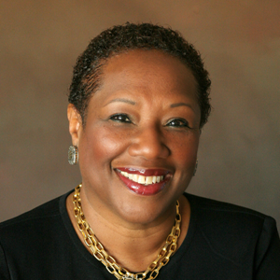

memorial Service

Saturday August 22, 2020

1:00pm EST

Online Memorial Service  
Rev. Robert L Martin, Sr.- Officiating

A POEM

I would like to be KNOWN

as an *intelligent* woman,

a *courageous* woman,

a *loving* woman,

a *woman who teaches*

by being.

-Maya Angelou

ACKNOWLEDGEMENT

Our family wishes to express our sincere thanks for the scholarship contributions and other expressions of love during our time of bereavement.

jacqueline e woods  
October 10, 1947 – July 27, 2020

Order of Service

*Gathering of Friends and Family*

Participants are encouraged to speak to each other and family members online before the service begins.

Processional...................."Nearer to Thee" Video Tribute

Invocation…………………....Rev. Robert L Martin, Sr.

Scripture Reading

Old Testament………….… Ariel Montes Kemp

New Testament……………….. John E Kemp Jr.

Acknowledgements & Resolutions

Obituary: Read Silently

Family Remembrances

Oldest Grandson………………….Gabriel Kemp

Youngest Sister…………….……….Anita May

Son…………………………….John "Bo" Kemp

Eulogy......................................Rev. Robert L Martin, Sr.

Recessional………………………"Sadie" Video Tribute

*Digital Repast*

Participants are encouraged to remain online to speak to each other and family members.

*Honorary Pallbearers*

Brian Owens, Michael Chastine Sr., Gabriel Kemp, John Kemp Jr, Dylan Smith, Michael Chastine Jr.

Obituary

Jacqueline E Woods passed on July 27, 2020 in Scottsdale, Arizona. Born and raised in Detroit as the oldest of three girls, Jackie is a graduate of Cass Technical High School as well as Michigan State and Wayne State Universities.

Professionally, she served as a presidential appointee of President Bill Clinton in the US Department of Education as the Director of the Community College Liaison Office. Jackie was also the former head of the American Association of University Women, a leading advocacy organization for education and equity for all women and girls.

She leaves behind two sisters, Carolyn Edwards and Anita May and her son Bo Kemp and his family.

A more detailed obituary and a permanent memorial site is available at: www.JackieWoods1010.com

Matthew 11:28-30

“Come to me, all you who are weary and burdened, and I will give you rest. Take my yoke upon you and learn from me, for I am gentle and humble in heart, and you will find rest for your souls. For my yoke is easy and my burden is light.”